**AirProbe Assignment**

**Problem statement**:

Build and train a system to detect if a given image is of a Vada-pav or not!

1. Data collection

* All the images are stored in data folder. Nearly 160 images are collected initially divided into vadapav and non vadapav folders.
* 40 images are kept for validation

1. Data augmentation

* Over 1920 images are formed with rotating, resizing, zooming in the images.
* Model is being trained on all these augmented images.

1. Model training

* Model is trained on CNN architecture.
* Keras is used
* **Binary cross entropy** is used to calculate the error for prediction.
* **Softmax** is used as activation function
* With this model I achieved 65 % accuracy.

Initial training of the model

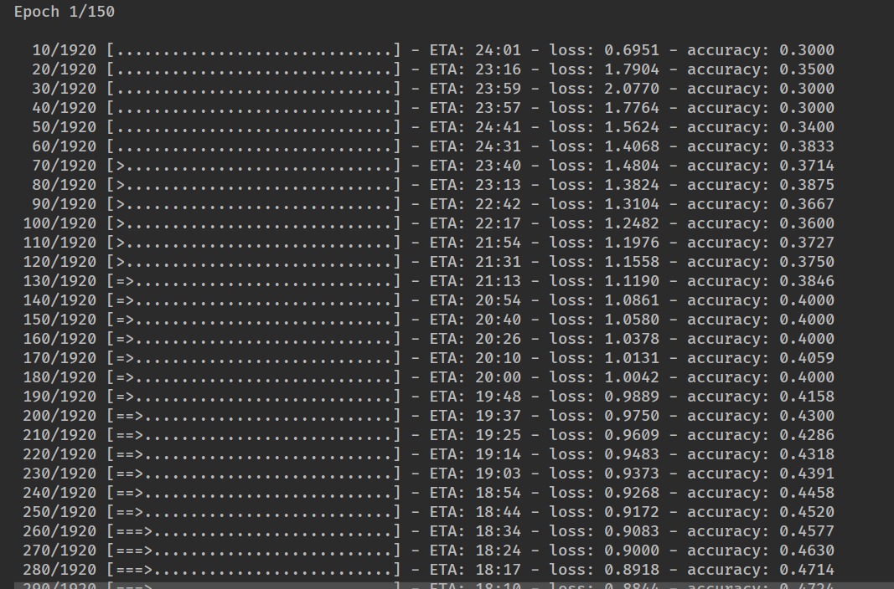

After many epochs model trained

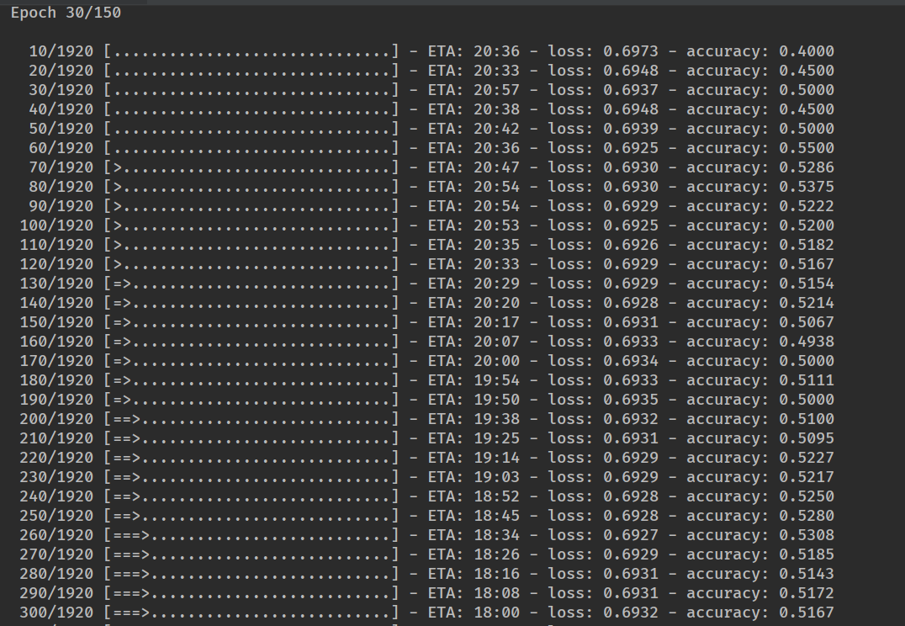

1. Improvements to model

* Image segmentation can be added.
* Transfer learning using ResNet

Folder structure :

Data -> contains all images

Data ->Train : Contains all images used for training the model.

Dta -> test : Contais all the images used for

Model -> Contains models and weights saved for future use.

Google drive link

<https://drive.google.com/drive/folders/11fQgDiDWtlPDUZtynYIvKUUEXXABzUs4>